**ASSIGNMENT 1: SMART HOME AUTOMATION WITH SENSORS USI ARDUINO UNO**

**SOFTWARE COMPONENT: TINKERCAD**

**OBJECTIVE:** The main objective of this project is to develop a home automation system using an Arduino board having to main functions:

* Automatically turn ON/OFF the lights when a person enters or leaves the room.
* Automatically turn ON/OFF the fan when a person enters or leaves the room.

**CIRCUIT DESIGN:**

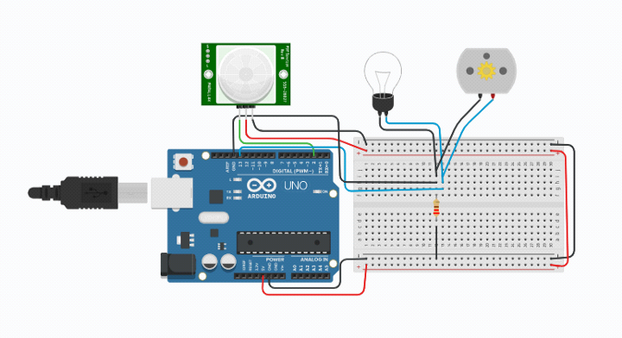

**CODE:**

int pirsensor = 0;  
 void setup()//the setup routine runs once when you press reset  
 {  
 pinMode(13,OUTPUT);//initialize digital 13 pin as an output  
 pinMode(12,INPUT);//initialize digital 12 pin as an input  
 }  
 void loop()//the loop routine runs multiple times  
 {  
 pirsensor = digitalRead(2);  
 if (pirsensor ==HIGH)  
 {  
 digitalWrite(13,HIGH);  
 delay(10000);  
 }  
 else  
 {  
 digitalWrite (13,LOW);  
 delay(120);  
 }  
 }

**OUTPUT/SIMULATION:** when the object is in range

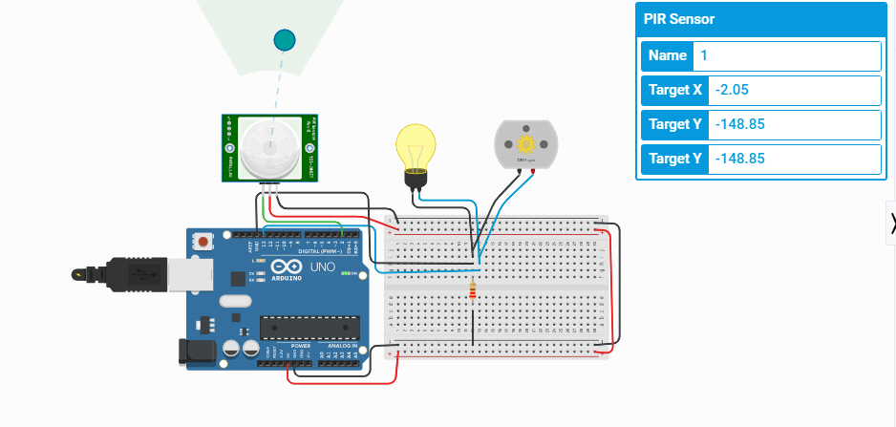

**OUTPUT/SIMULATION:** when the object is not in the range

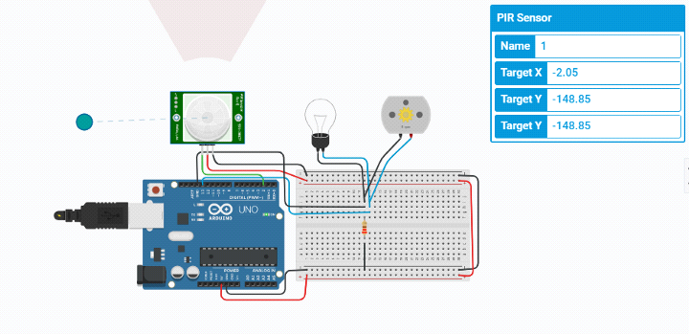

**NAME: BEBISHA THERESE.G**

**REG NO: 963019104002**